**Date Submitted: 10/9/18**

**------------------------------------------------------------------------------------**

**Task 01:**

**#include** <stdint.h>

**#include** <stdbool.h>

**#include** <math.h> // enables us to use the sinf()

**#include** "inc/hw_memmap.h"

**#include** "inc/hw_types.h"

**#include** "driverlib/fpu.h" // enables us to use Floating Point Units

**#include** "driverlib/sysctl.h"

**#include** "driverlib/rom.h"

//

**#ifndef** M_PI

**#define** M_PI 3.14159265358979323846

**#endif**

**#define** SERIES_LENGTH 100 // the depth of our data

**float** gSeriesData[SERIES_LENGTH]; // an array of floats

int32_t i32DataCount = 0; // counter for math loop

**int** **main**(**void**)

{

**float** fRadians; // calculate sine

ROM_FPULazyStackingEnable();

ROM_FPUEnable(); // Enable Floating Points

// 50MHz System Clock

ROM_SysCtlClockSet(SYSCTL_SYSDIV_4 | SYSCTL_USE_PLL | SYSCTL_XTAL_16MHZ | SYSCTL_OSC_MAIN);

fRadians = ((2 * M_PI) / SERIES_LENGTH); // getting a full sine wave

// Calculate the sine value for each angle

**while**(i32DataCount < SERIES_LENGTH)

{

gSeriesData[i32DataCount] = **sinf**(fRadians * i32DataCount);

i32DataCount++;

}

**while**(1)

{

}

}

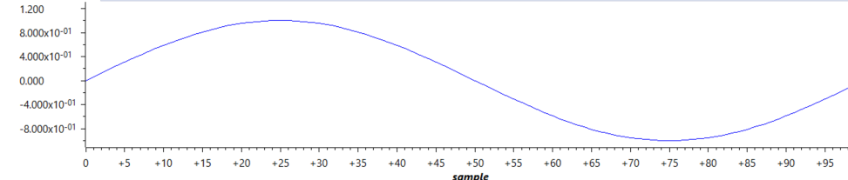

**------------------------------------------------------------------------------------**

**Task 02:**

**#include** <stdint.h>

**#include** <stdbool.h>

**#include** <math.h> // enables us to use the sinf()

**#include** "inc/hw_memmap.h"

**#include** "inc/hw_types.h"

**#include** "driverlib/fpu.h" // enables us to use Floating Point Units

**#include** "driverlib/sysctl.h"

**#include** "driverlib/rom.h"

//

**#ifndef** M_PI

**#define** M_PI 3.14159265358979323846

**#endif**

**#define** SERIES_LENGTH 100 // the depth of our data

**float** gSeriesData[SERIES_LENGTH]; // an array of floats

int32_t i32DataCount = 0; // counter for math loop

**int** **main**(**void**)

{

**float** fRadians; // calculate sine

**float** sine;

**float** cosine;

ROM_FPULazyStackingEnable();

ROM_FPUEnable(); // Enable Floating Points

// 50MHz System Clock

ROM_SysCtlClockSet(SYSCTL_SYSDIV_4 | SYSCTL_USE_PLL | SYSCTL_XTAL_16MHZ | SYSCTL_OSC_MAIN);

fRadians = ((2 * M_PI) / SERIES_LENGTH); // getting a full sine wave

// Calculate the sine value for each angle

**while**(i32DataCount < SERIES_LENGTH)

{

sine = **sinf**(fRadians * 50 * i32DataCount);

cosine = **cosf**(fRadians * 200 * i32DataCount);

gSeriesData[i32DataCount] = 1.5 + sine + cosine;

i32DataCount++;

}

**while**(1)

{

}

}



